Gesture controlled bot using arduino
Aim:
The main to develop the Gesture controlled bot is that Gesture controlled bot can be used in many ways as we can reduce its size and further manipulation can helps us to control a bot easily as we don't need to carry an external controller as it runs with the help of our hand gesture and further we can make it as much compact that we can control a spy bot using our hand gestures only and it helps us to learn that how a gyrosensor works.

Components used:
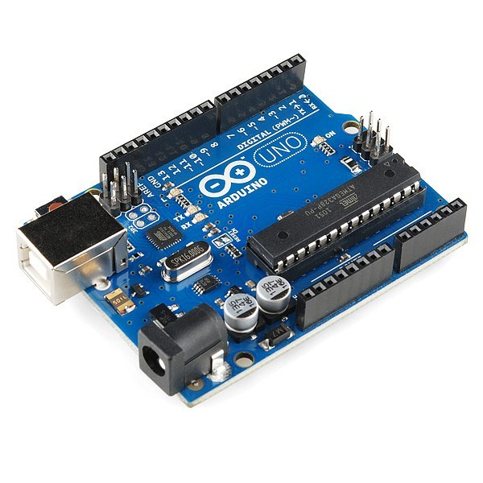
Arduino:Overview. The Arduino Uno is a microcontroller board based on the ATmega328. It has 20 digital input/output pins (of which 6 can be used as PWM outputs and 6 can be used as analog inputs), a 16 MHz resonator, a USB connection, a power jack, an in-circuit system programming (ICSP) header, and a reset button.

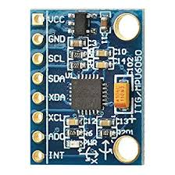
MPU6050:The MPU 6050 is a sensor based on MEMS (micro electro mechanical systems) technology. Both the accelerometer and the gyroscope are embedded inside a single chip. This chip uses I2C (inter-integrated circuit) protocol for communication.

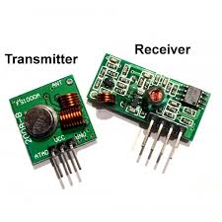
RF transmitter and receiver:An RF transmitter receives serial data and transmits it wirelessly through RF through its antenna connected at pin4. The transmission occurs at the rate of 1Kbps – 10Kbps. The transmitted data is received by an RF receiver operating at the same frequency as that of the transmitter.
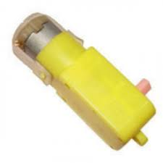
BO Motor: BO (Battery Operated) light weight DC geared motor which gives good torque and rpm at lower voltages. This motor can run at approximately 200 rpm when driven by a single Li-Ion cell. Great for battery operated light weight robots. It can do reverse and forward directions.
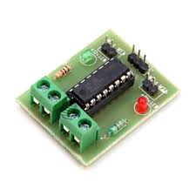
Motor driver: The L293D is designed to provide bidirectional drive currents of up to 600-mA at voltages from 4.5 V to 36 V. Both devices are designed to drive inductive loads such as relays, solenoids, dc and bipolar stepping motors, as well as other high- current/high-voltage loads in positive-supply applications.
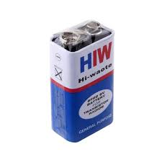
Batteries: The nine-volt battery, or 9-volt battery, is a common size of battery that was introduced for the early transistor radios. It has a rectangular prism shape with rounded edges and a polarized snap connector at the top. This type is commonly used in walkie-talkies, clocks and smoke detectors.

Working:
To make a gesture controlled bot, 2 Arduino UNOs were used. 1st Arduino was receiving the x,y,z coordinates from the gyro sensor of the MPU6050 module and then transferring in through the transmitter of rf transmitter and reciever pair and then 2nd arduino recieves the values from the reciever and then directs the motor driver to make the bot move in all the directions.

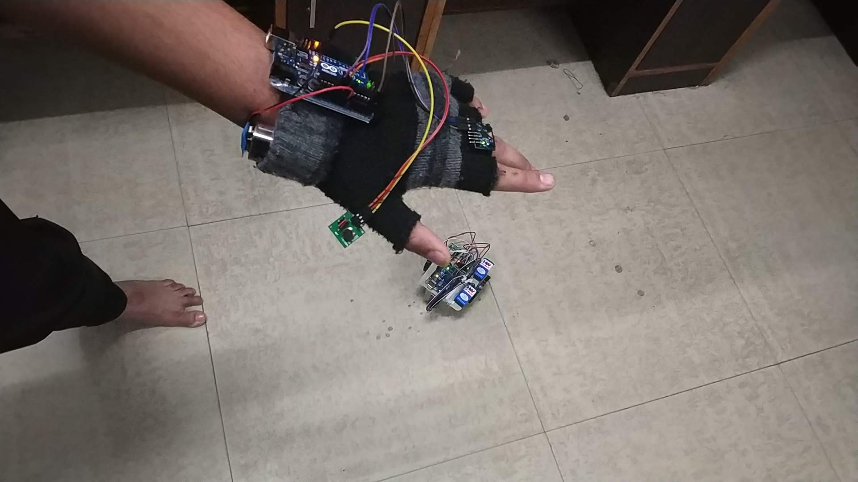
Images and video as follows:
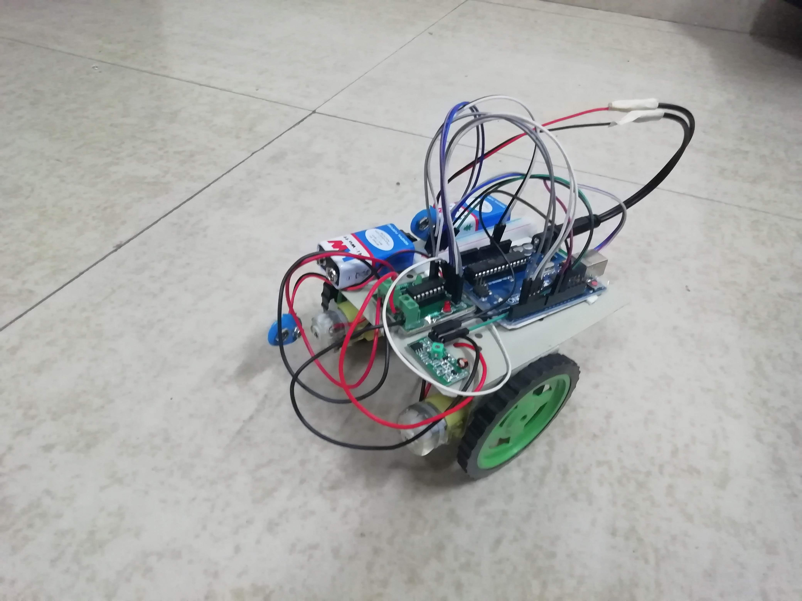
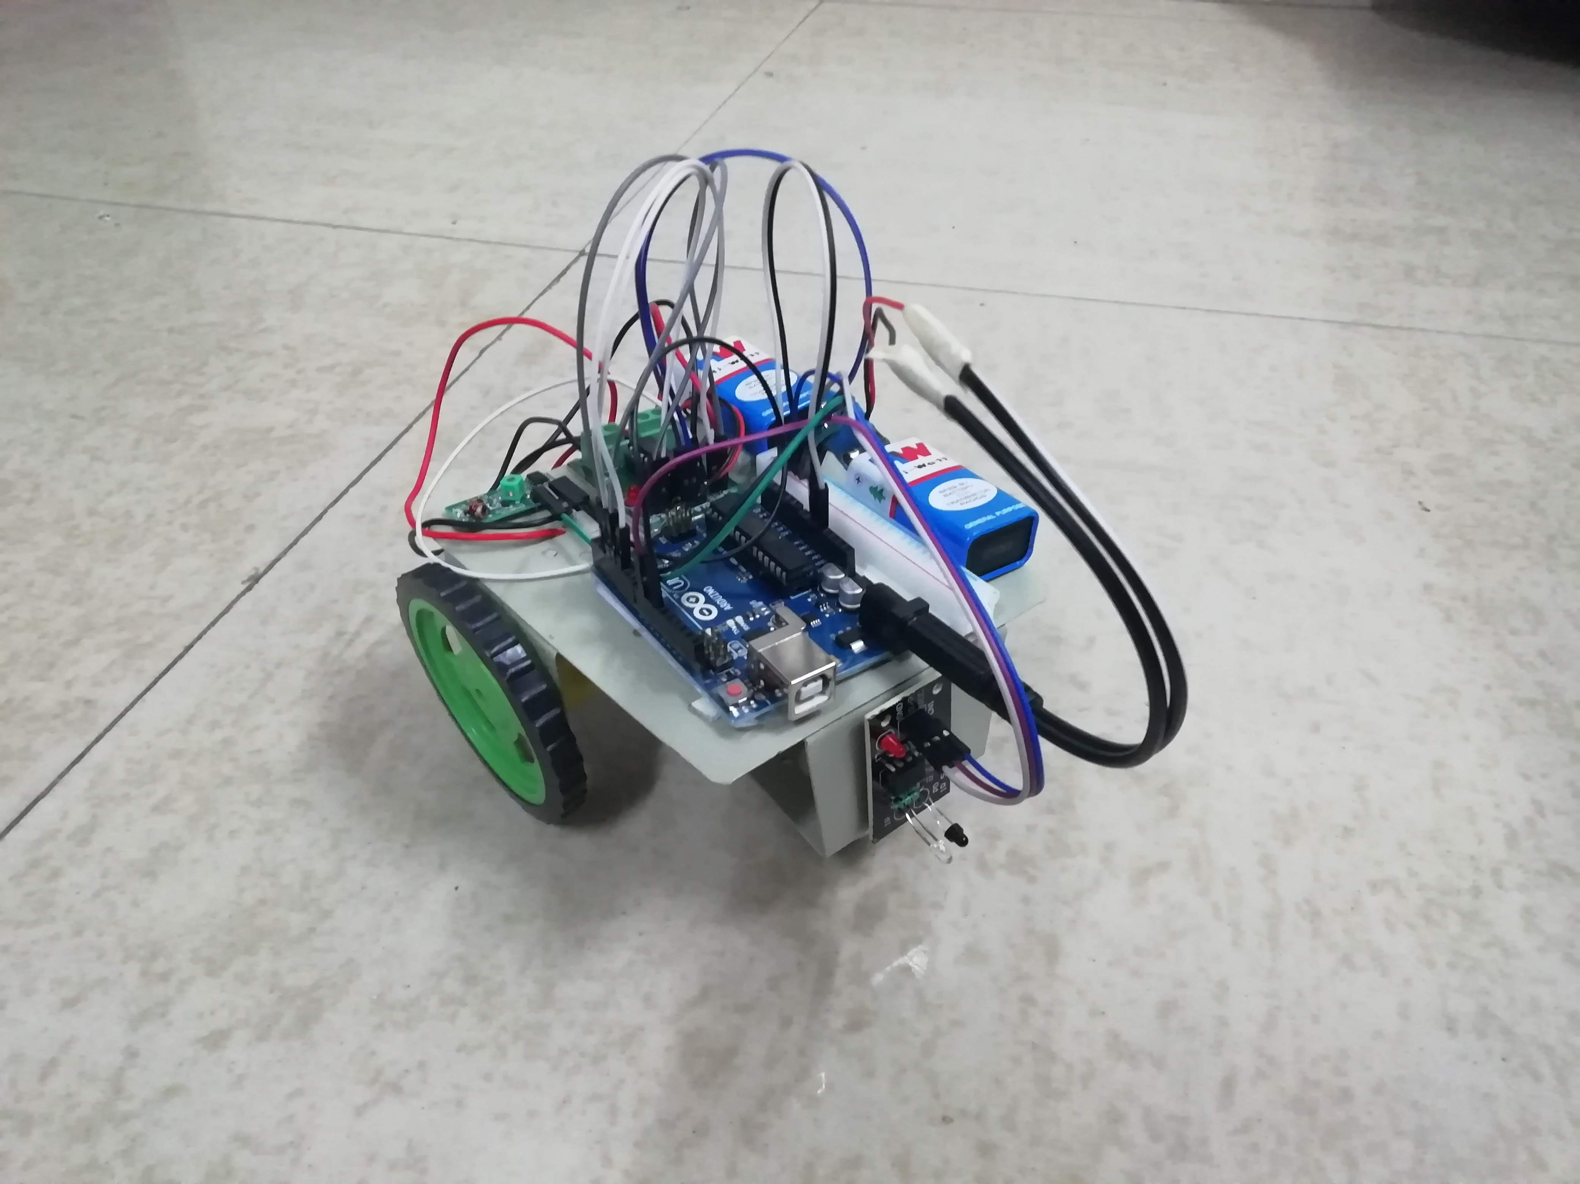

https://drive.google.com/open?id=1zOqLE4VPnRHbECyHWLARldQpeWpBmDsN

